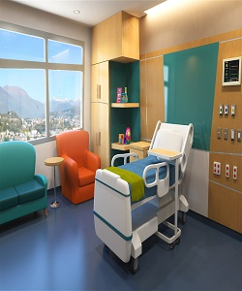

Rosewood hospital bed

$150.32

Availability: In stock

**Description:**

High end, modern contemporary Astrid Solid Walnut electrical Platform Bed has amazing legs. Minimalist Zen design, handcrafted in Vermont of natural walnut steel.Matress is high quality that gives your patient full comfort.